Movie Ticket Booking Kiosk
GUI Manual
Denise Kethley Caña

Introduction
Welcome to the Movie Ticket Booking Kiosk System: Graphical User Interface (GUI) Manual. This document provides a comprehensive guide for understanding and operating the kiosk-based movie ticket booking system. The system allows customers to browse movies that are currently showing as well as upcoming movie releases, view essential movie information such as ratings, descriptions, and showtimes, and proceed with ticket booking transactions through an interactive kiosk interface. This manual serves as a reference to help system administrators and staff understand the system’s features, navigation, and operational processes in order to ensure efficient management and use of the kiosk system.

Rationale
Traditional cinema ticket purchasing often relies on manual transactions at ticket counters, which can lead to long waiting times, operational delays, and inconvenience for customers during peak hours. To address these challenges, the Movie Ticket Booking Kiosk System was developed to provide a more efficient and automated method of accessing movie information and processing ticket bookings. Through a digital kiosk interface, customers can conveniently browse currently showing and upcoming movies and initiate booking transactions, while staff and administrators can manage movie listings, schedules, and transaction records in a more organized and systematic manner.

Significance
The implementation of the Movie Ticket Booking Kiosk System contributes to improving the efficiency and accessibility of cinema ticketing services. By providing an automated platform for displaying movie information and handling ticket booking transactions, the system helps reduce congestion at ticket counters and enhances the overall customer experience.

The GUI manual will first present the operational guidelines for system administrators, followed by the procedures intended for staff members responsible for handling booking transactions.
ADMINISTRATOR: MANUAL

Main Landing Page Overview
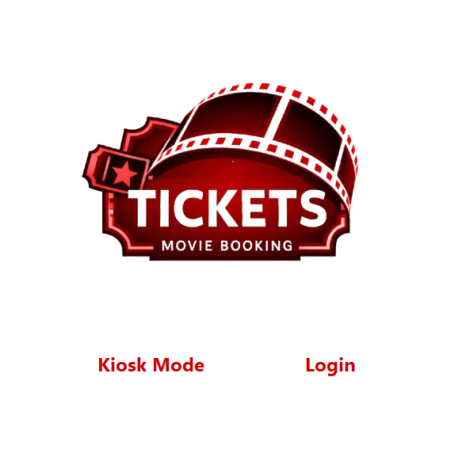

Upon starting the MTB (Movie Ticket Booking Kiosk) application, users are presented with the Main Landing Page, which allows them to choose between two primary modes:
- Kiosk Mode – Intended for self-service booking terminals used by customers.
- Login – Intended for system administrators and staff members responsible for managing bookings.

LOG IN PAGE
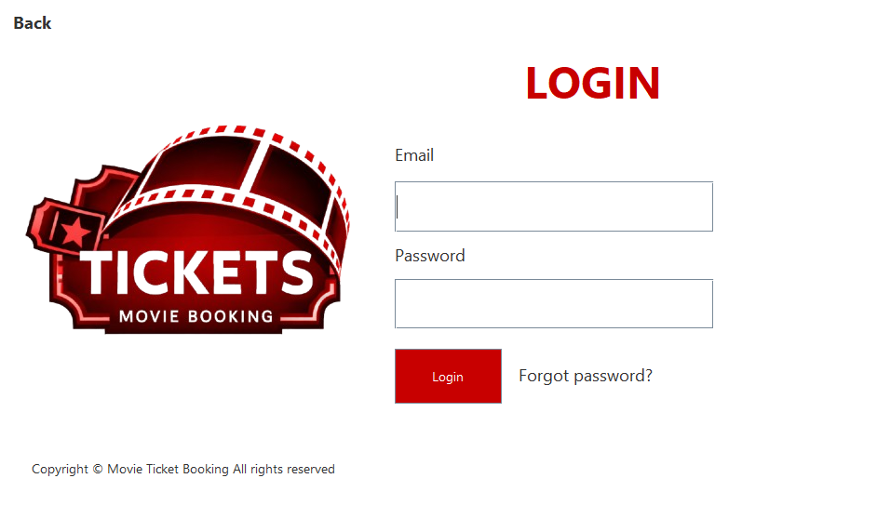

• Upon starting the application, the user will be redirected to the Login Page.
• The user must enter their username and password in the designated fields to access the system.
• After providing the required credentials, the user may click the Log In button to proceed to the system interface.
• Only users with existing and active accounts provided by the administrator are allowed to access the system.
• Accounts that are inactive or not yet activated will not be able to log in until they are activated by an administrator.

Disclaimer: Some actions are still under development. The developer is still working on it.

ADMIN: DASHBOARD
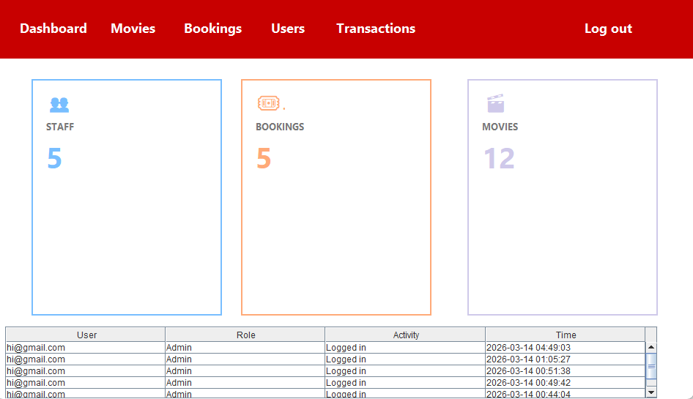

If the user logs in with an administrator account, they will be redirected to the Admin Dashboard.
• The dashboard provides an overview of the system’s data, including the total number of staff, bookings, and movies.
• The administrator can navigate the system using the navigation panel to access the Movies, Bookings, Users, and Transactions sections.
• The dashboard also displays recent activity logs showing system actions performed by users.
• The administrator may choose to Log Out of the system through the Log out option in the navigation panel.

ADMIN: MOVIE MANAGEMENT
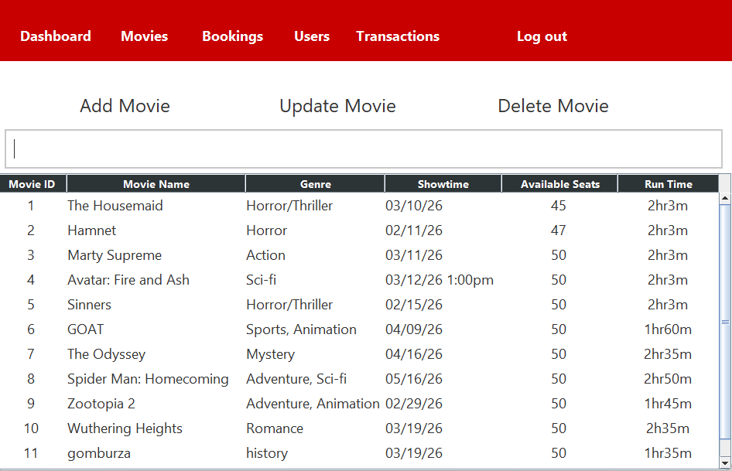

• The Movie Management page allows the administrator to manage all movies stored in the system database.
• The movie table displays important details such as Movie ID, Movie Name, Genre, Showtime, Available Seats, and Run Time.

ADMIN: MOVIE MANAGEMENT
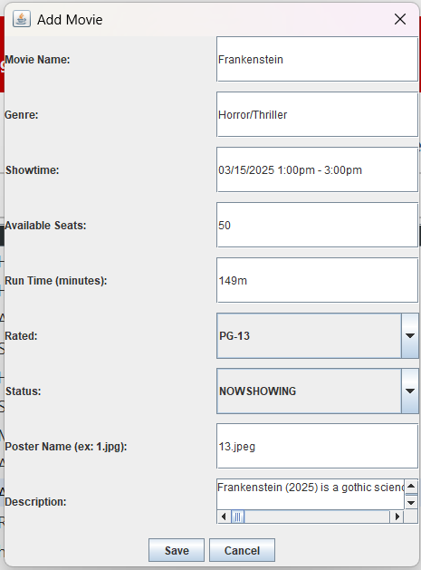

• The administrator can add a new movie by clicking Add Movie, which opens a form where information such as movie name, genre, showtime, seats, runtime, rating, status, poster name, and description can be entered.
• To edit a movie, the administrator must first select a movie from the table, then click Update Movie to modify its details.
• The administrator can remove a movie from the system by selecting it and clicking Delete Movie, followed by confirming the deletion.
• A search field is available to quickly find movies by typing keywords such as the movie name, genre, showtime, or other related details.
ADMIN: BOOKING MANAGEMENT
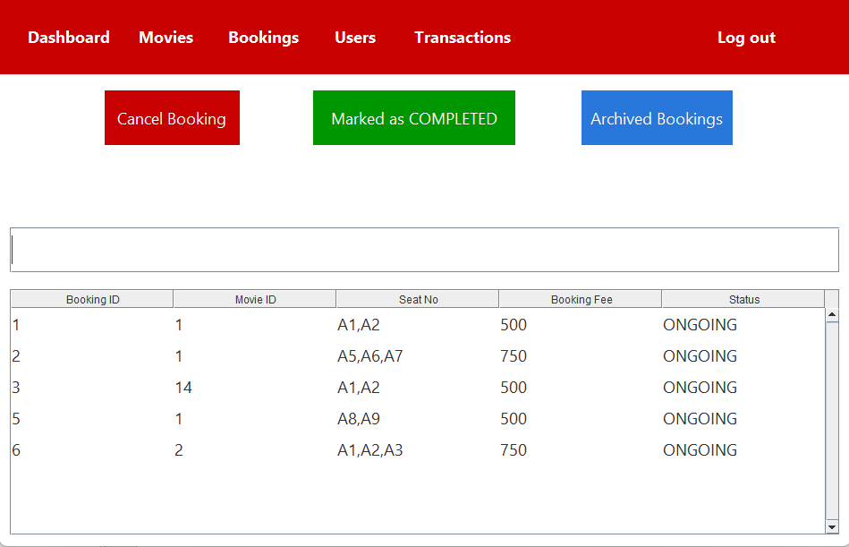

• Booking Table:
Shows Booking ID, Movie ID, Seats, Total, Status, Date; supports case-insensitive search. Row selection required for actions.
• Cancel Booking:
Select a booking, enter a cancellation reason, then confirm. Table reloads after successful cancellation.
• Mark as Completed:
Select a booking to update its status to COMPLETED. Table reloads automatically.
• Archived Bookings:
Click the button to view archived bookings in a separate interface.

ADMIN: BOOKING MANAGEMENT (ARCHIVE BOOKINGS)
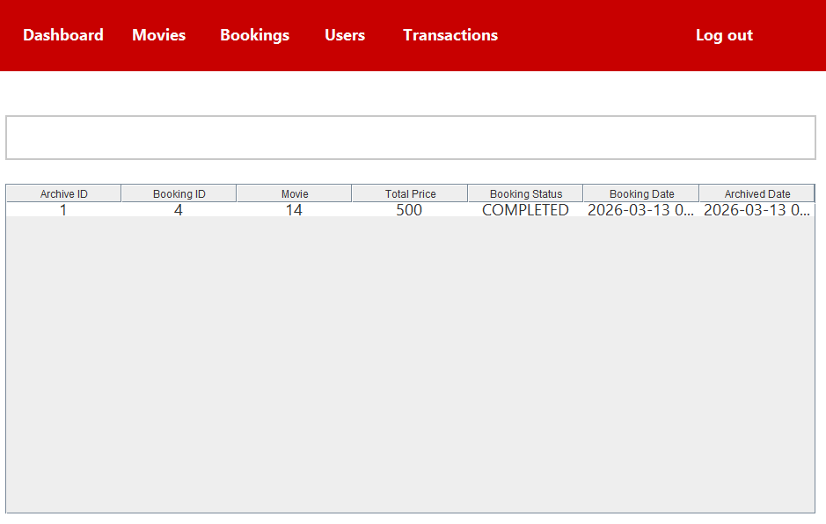

- Access: Open the Archived Bookings page from the Admin menu.

- Table View: Displays Archive ID, Booking ID, Movie ID, Total Price, Booking Status, Booking Date, and Archived Date. Entries are read-only.

- Search & Filter: Use the search bar to filter by Booking ID, Movie Name, Movie ID, or Status. Search is case-insensitive. Clearing the field shows all archived bookings.

- Validation: Search requires alphanumeric input. Blank input restores the full table.

Important Notes: Archived bookings are permanent and cannot be edited or deleted. Always verify Booking ID and Movie details before taking related actions. Columns are centered for clarity.

ADMIN: USER MANAGEMENT
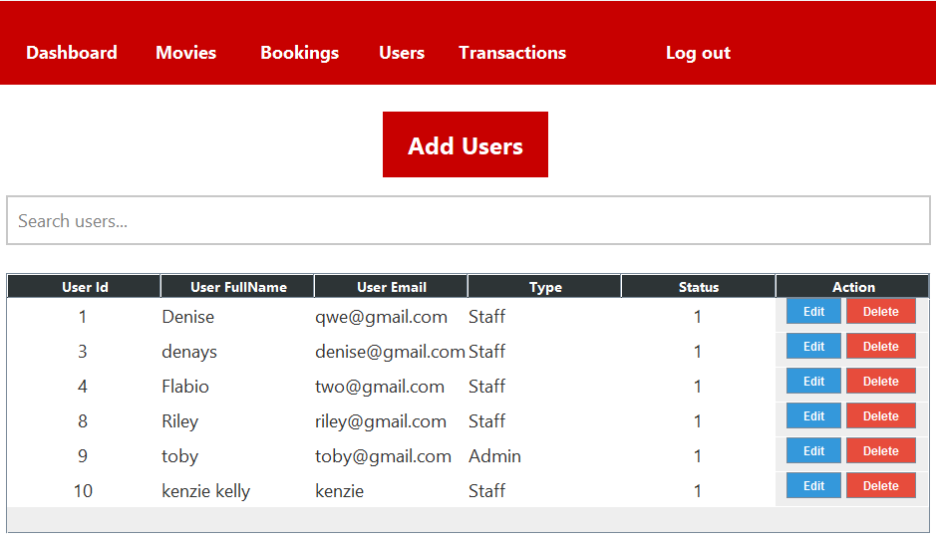

User Table
- Displays the following columns: User ID, Full Name, Email, Password (hidden), Type, Status, and Action.
- Supports case-insensitive search and filtering.
- Selecting a row is required to perform any edit actions.
- The currently logged-in administrator is excluded from edit operations.
Deleting a User
- Click the Delete button in the Action column corresponding to the user you wish to remove.
- The logged-in administrator cannot be deleted.
- A confirmation dialog appears to prevent accidental deletion.
- Upon confirmation, the user is removed from the database.
- The user table refreshes automatically to reflect the deletion.

ADMIN: USER MANAGEMENT
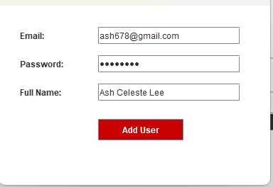

Adding a New User
- Click Add Users to open the Add User dialog.
- Complete all required fields: Email, Password, and Full Name.
- Validation Rules:
  - All fields must be completed.
  - Email addresses must be unique; duplicates are not allowed.
- Upon successful addition, the new user is assigned the role staff and status pending
- The table refreshes automatically to display the newly added user.
Updating a User
- Click Edit in the Action column corresponding to the desired user.
- Validation Rules:
  - The logged-in administrator cannot be edited.
  - No field can be left empty.
- All changes are saved to the database, and the table updates automatically to reflect the edits.
ADMIN: TRANSACTION MANAGEMENT
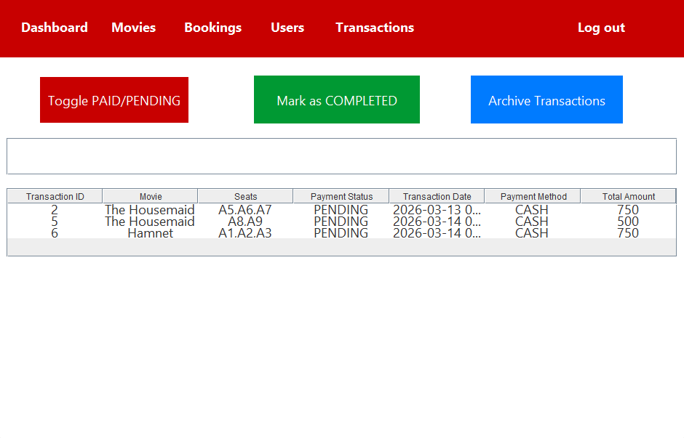

- Access: Open the Transaction Management page from the Admin menu.

- Table View: Displays Transaction ID, Movie, Seats, Payment Status, Transaction Date, Payment Method, and Total Amount. All entries are viewable and sortable; you cannot edit them directly.

- Search & Filter:
Use the search bar to filter transactions by Transaction ID, Movie Name, Payment Method, or Date.
Search is case-insensitive.
Clearing the search field restores the full table.

- Toggle Payment Status:
Select a transaction row and click “Toggle PAID/PENDING” to change its payment status.

Validation: You must select a transaction first. Status updates are saved immediately.

- Mark as Completed:
Select a transaction row and click “Mark as COMPLETED” to archive it.
The transaction is moved to the archive table and removed from the main table.

Validation: You must select a transaction before marking it completed.

- Archive Transactions:
Click “Archive Transactions” to view all completed transactions in the archived section.
Archived transactions are permanent and cannot be modified or deleted.

Important Notes:
- Always verify transaction details before toggling status or archiving.
- Table columns are centered for easier reading.

ADMIN: TRANSACTION MANAGEMENT (ARCHIVE TRASANCTIONS)
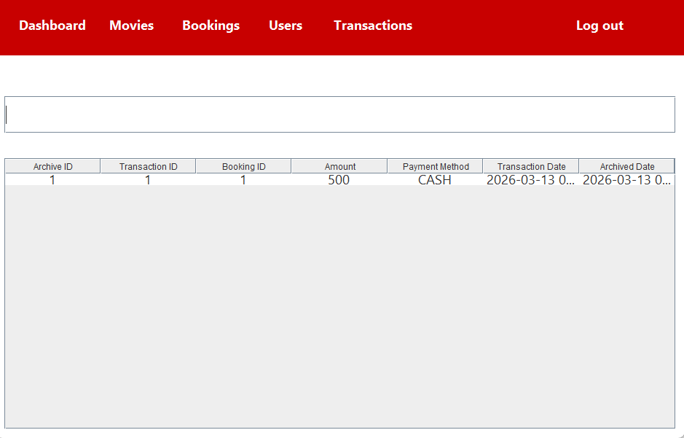

Table Overview:
- Shows Archive ID, Transaction ID, Booking ID, Amount, Payment Method, Transaction Date, and Archived Date. All entries are read-only.
Search Transactions:
- Use the search bar to find transactions by Archive ID, Transaction ID, Booking ID, or Payment Method. Search is case-insensitive.
- Clearing the search field will display all archived transactions.
Important Notes:
- Archived transactions cannot be edited or deleted.
- Always verify transaction and booking details before performing actions in other modules.
- Table columns are centered for easy reading.

STAFF: DASHBOARD
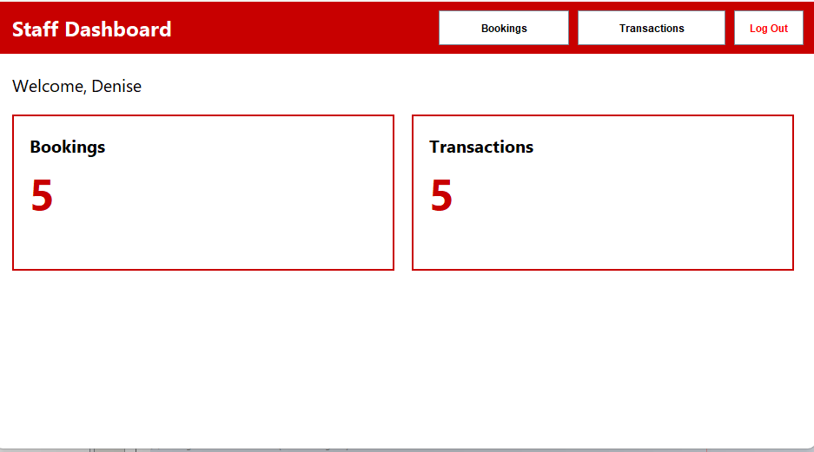

- Access: Login to the system using your staff credentials.
- Welcome Message: Displays your name for personalized access.
  - Validation: If name cannot be fetched from the database, a default "User" is shown.
- Navigation Bar:
  - Bookings: View and manage all bookings.
  - Transactions: View and manage all transactions.
  - Log Out: Ends your session after confirmation.

- Dashboard Cards: Quick summary of key data:
  - Shows total bookings and total transactions.
  - Validation: Counts are fetched live; if database is unreachable, count defaults to 0.
- Search and Interaction: Use buttons and cards to navigate between modules easily.
Notes:
- Always verify actions before updating bookings or transactions.
- Log out properly to clear the session.
- Dashboard is read-only for summary counts; detailed edits happen in respective modules.

STAFF: BOOKING MANAGEMENT
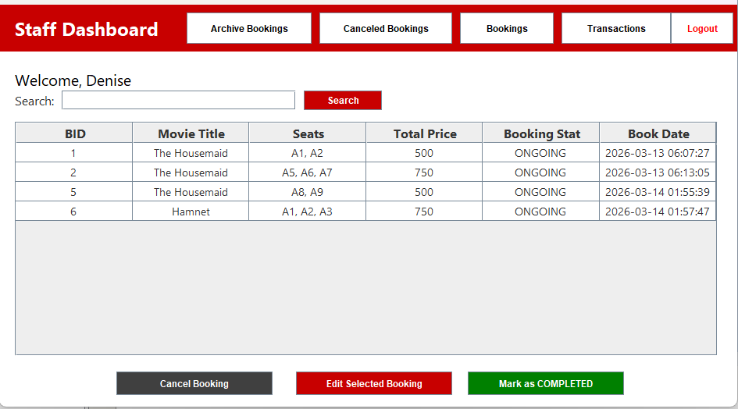

- Navigation: Access via Staff Dashboard. Switch between Bookings, Archive, Canceled, and Transactions. Logout with confirmation.
- Booking Table: Shows active bookings (BID, Movie, Seats, Price, Status, Date). Read-only. Search by ID or movie. Displays message if no results.
Actions:
- Edit: Update total price (select booking; numeric validation).
- Mark as COMPLETED: Update status and archive (requires selection; ensures transaction succeeds).
- Cancel: Cancel with reason (selection and non-empty reason required).

Notes: Maintains data integrity, provides clear instructions, and supports efficient workflow.

STAFF: CANCELED BOOKINGS
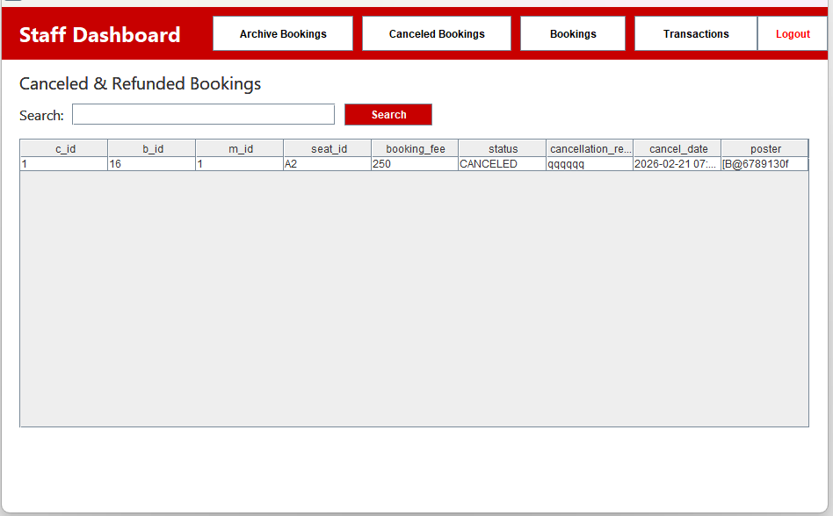

Access & Navigation:
- Accessible from Staff Dashboard via the "Canceled Bookings" button.
- Navigate between Bookings, Archive Bookings, Canceled Bookings, and Transactions.
- Logout button ends session with confirmation.
Canceled Booking Table:
- Displays all canceled/refunded bookings with relevant details (BID, Movie, Seats, Total Price, Status, Cancellation Date).
- Read-only table to prevent accidental edits.
Validation: Shows message if no matching records found.

STAFF: ARCHIVE BOOKINGS
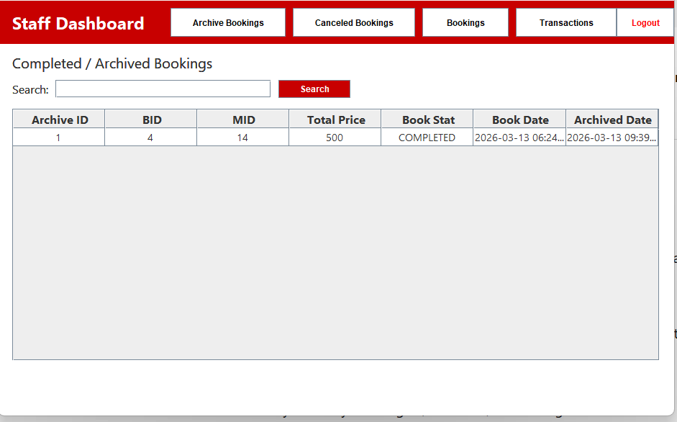

Access & Navigation:
- Accessible from Staff Dashboard via the "Archive Bookings" button.
- Navigate seamlessly between Bookings, Canceled Bookings, Archived Bookings, and Transactions.
- Logout button ends session with confirmation.
Archive Booking Table:
- Displays all completed/archived bookings with columns: Archive ID, BID, MID, Total Price, Booking Status, Booking Date, and Archived Date.
- Read-only table to prevent accidental edits.
- Search functionality filters by Booking ID, Movie ID, or Booking Status.
- Validation: Displays an error message if no matching archived bookings are found.
STAFF: TRANSACTION MANAGEMENT
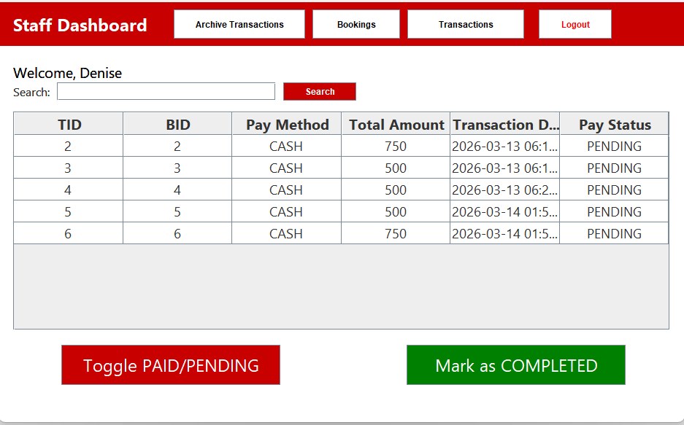

Access & Navigation:
  - Via "Transactions" button on Staff Dashboard.
  - Navigate between Bookings, Archived Transactions, and Transactions.
  - Logout with confirmation.
Transaction Table:
  - Shows TID, BID, Payment Method, Amount, Date, and Status.
  - Read-only; searchable by TID, BID, or Status.
  - Alerts if no results found.

Transaction Actions:
  - Toggle PAID/PENDING: Updates payment status (requires selection).
  - Mark as COMPLETED: Archives selected PAID transactions (ensures database success).
Notes:
  - Validated, transaction-safe operations.
  - Clear, professional, and efficient interface for staff.

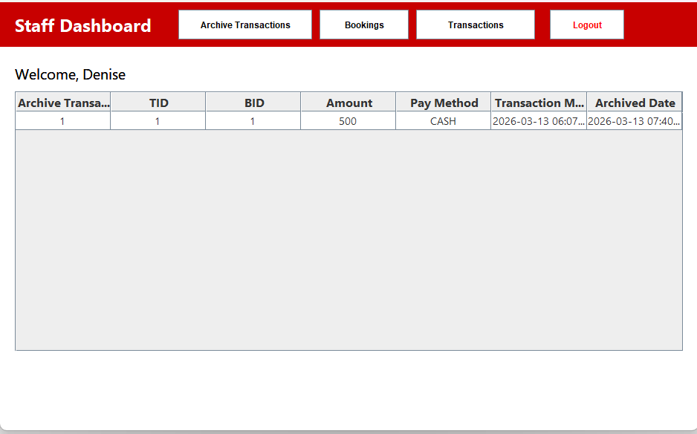
STAFF: ARCHIVE TRASANCTION

Access & Navigation:
- Accessible from Staff Dashboard via "Archive Transactions" button.
- Navigate between Bookings, Transactions, and Archived Transactions.
- Logout button ends session with confirmation.
Archive Transaction Table:
- Displays archived transactions with columns: Archive Transaction ID, TID, BID, Amount, Payment Method, Transaction Method, and Archived Date.
- Read-only table; prevents edits or column reordering/resizing.
- Ensures all data is properly loaded from database; alerts on errors.
Validation & Notes:
- Table loads only existing archived transactions; empty or missing records handled gracefully.
LOG OUT

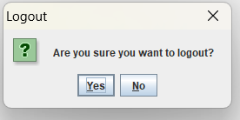

Confirmation Dialog:
- Displays message: “Are you sure you want to logout?” with Yes and No options.
- Yes: Ends current session and redirects user to the Login page.
- No: Cancels logout and keeps user on the current dashboard.
Validation & Notes:
- Ensures accidental logouts are prevented via confirmation prompt.
- Session termination is handled securely, preventing access to restricted pages without re-login.


Main Landing Page Overview

- Kiosk Mode – Intended for self-service booking terminals used by customers.

Note: User Choose Kiosk Mode will be directed to Kiosk Home Display

KIOSK MODE



• If user opens the kiosk, they are redirected to the Home landing page.
• Home displays the app logo at the top center.
• Home shows featured movie posters on the left and right.
• User can start booking by clicking the “Click to Start Booking” button.
• Clicking Start Booking opens the Now showing page for movie and seat selection.
• Start Booking closes the landing page to prevent duplicate windows.
• Back button is hidden but available to return safely to the main landing page.
• Back button closes the current page to avoid multiple windows.

KIOSK MODE: NOW SHOWING MOVIES
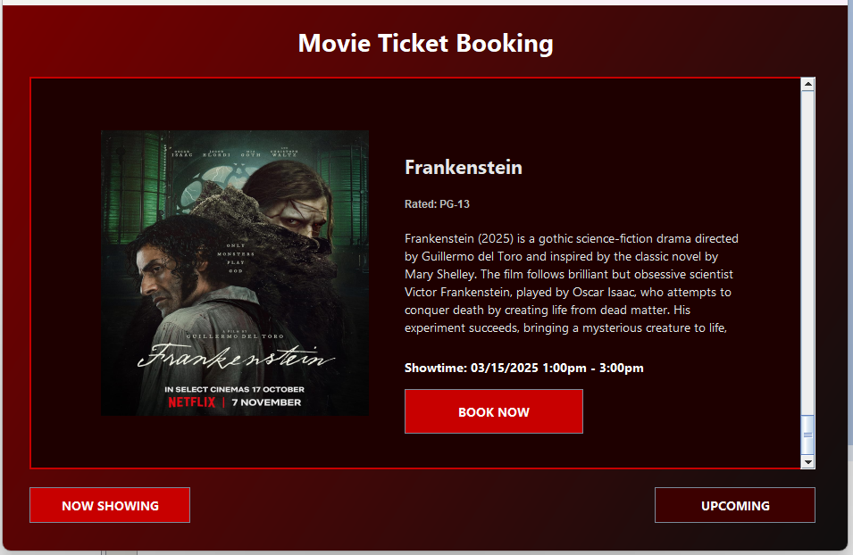

• When the kiosk opens, the user is redirected to the Now Showing page.
• Now Showing displays all movies currently available for booking.
• Each movie shows a poster, title, rating, brief description, and showtime.
• Users can click the BOOK NOW button to start booking tickets for that movie.
• Booking button is only enabled for movies that are currently showing.
• If a movie poster is missing, a placeholder image is displayed to maintain layout.
• The page layout is scrollable, touch-friendly, and prevents accidental closure or duplicate windows.
• Navigation and interactions are validated to ensure smooth booking and prevent errors.
KIOSK MODE: UPCOMING MOVIES
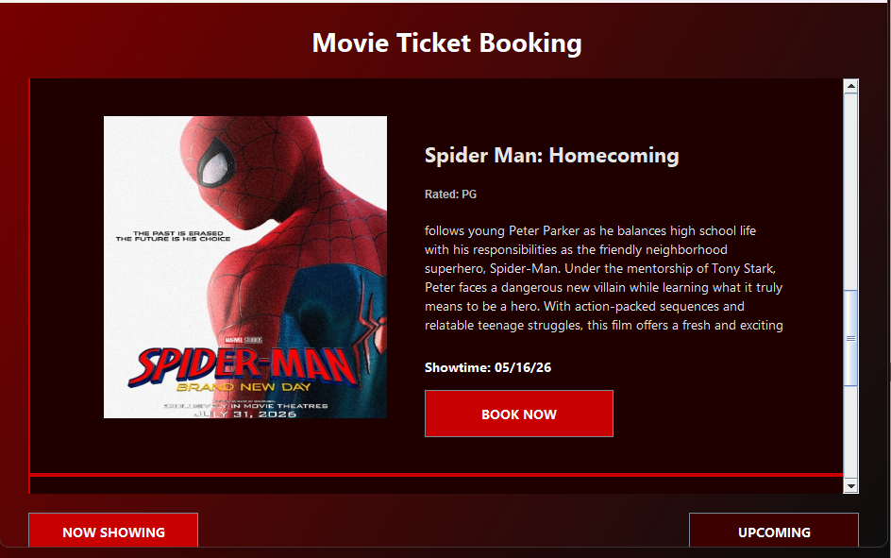

• When the kiosk opens the Upcoming section, users see movies that will be available soon.
• Each movie displays a poster, title, rating, description, and showtime.
• Users can click the BOOK NOW button to reserve tickets in advance.
• If a poster is missing, a placeholder image appears to maintain layout consistency.
• Booking and navigation are validated to ensure smooth operation and prevent errors.
• The page is scrollable, touch-friendly, and prevents duplicate windows or accidental closure.
KIOSK MODE: BOOKING
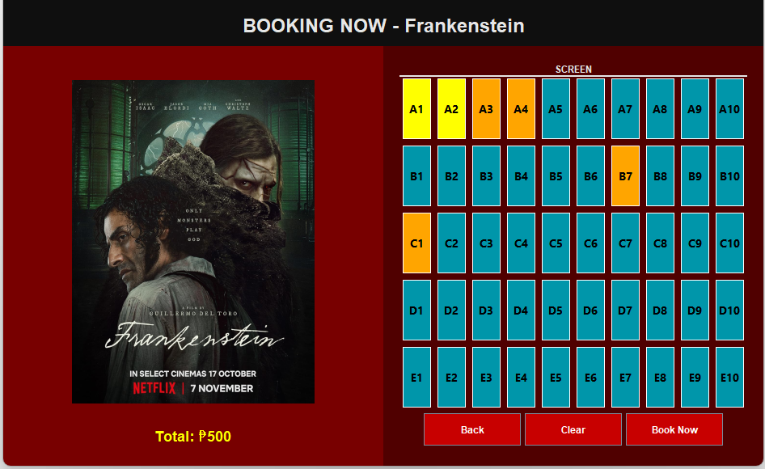

• When a user selects a movie, they are redirected to the Booking page for that movie.
• The page displays the movie poster, title, and rating on the left panel.
• Available seats are shown on the right panel with color codes for clarity:
– Gray: Seat already taken, cannot be selected.
– Orange: PWD/Wheelchair seat, selectable but reserved for accessibility.
– Blue/Green: Available seats for general booking.
– Yellow: Selected Seats.
• Users can select multiple seats, which turn yellow when chosen, and the total price updates automatically.
• Clear button deselects all selected seats.
• Book Now button validates seat availability before saving to prevent double booking.
• Back button safely returns to the Now Showing page without leaving duplicate windows.
KIOSK MODE: PAYMENT PROCESS
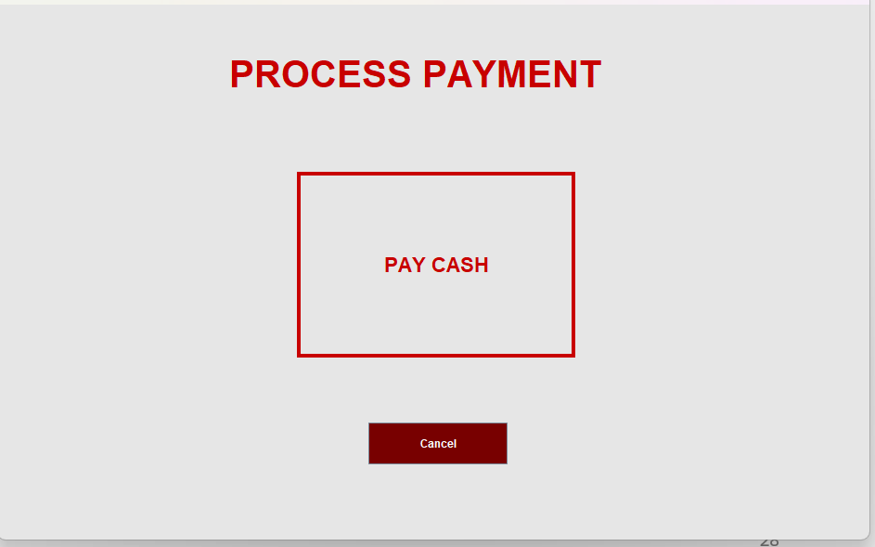

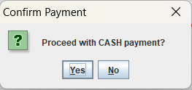
• After selecting seats, the user is redirected to the Process Payment page.
• The page displays the movie title, selected seats, and total amount due.
• Users can choose to pay via CASH by clicking the payment panel.
• Clicking CASH triggers a confirmation dialog to prevent accidental payments.
• If confirmed, the payment process continues to the Cash Payment page.
• Cancel button safely returns the user to the Booking page without losing selected seats.
• All actions are validated to prevent accidental closure, double booking, or payment errors.

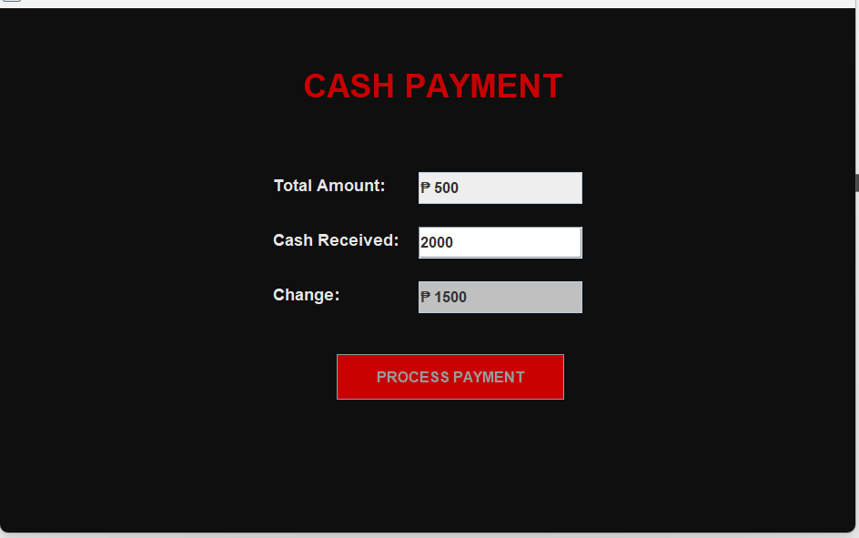
KIOSK MODE: CASH PAYMENT

• After confirming seat selection, the user is redirected to the Cash Payment page.
• The page shows the total amount due, a field to enter cash received, and a field to display change.
• Users enter the cash amount and click PROCESS PAYMENT to complete the transaction.
• Payment is validated to ensure the cash entered is sufficient; insufficient cash triggers an alert.
• The system calculates and displays the change automatically before completing the payment.
• All booking details, seats, and transactions are saved safely in the database using validated operations to prevent errors.
Note: After successful payment, the user is redirected to the Ticket page to view or print the booking.
KIOSK MODE: MOVIE TICKET
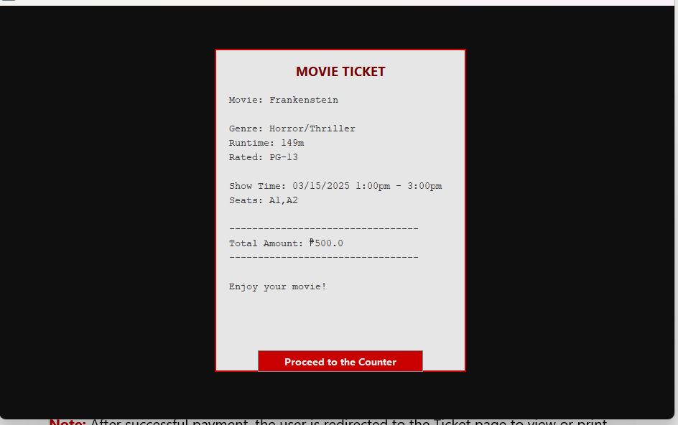

• After completing payment, the user is redirected to the Ticket page.
• The page displays a receipt with all booking details: movie title, genre, runtime, rating, showtime, selected seats, and total amount.
• Users can review the information to confirm correctness before proceeding.
• Proceed to the Counter button shows a thank-you dialog and instructs the user to finalize payment and collect the ticket at the counter.
• The system ensures all data displayed is retrieved safely from the database and matches the booking ID.
• Clicking Proceed closes the Ticket page and returns the user to the Kiosk Home page.
• The layout is clear, professional, and touch-friendly, optimized for kiosk use.
• Validation ensures the booking exists; if data is missing, the page handles it gracefully without errors.

